1. Description

For GUC students who want to offer their car for carpooling with other GUCians or for GUCians who want to search for available carpools in order to go to and come back from campus.

1. User Stories

2.1. As a GUCian I should be able to login.

2.2. As a GUCian I should be able to log out.

2.3. As a GUCian I should be able to search for available carpools.

2.4. As a GUCian I should be able to filter the available carpools such that they fit my niche requirements and/or preferences.

2.5. As a GUCian I should be able to view any carpool.

2.6. As a GUCian I can comment on any posted carpool.

2.7. As a GUCian I should be able to offer my commute as a possible carpool choice while specifying which seats are available (configuration feature).

2.8. As a GUCian I should be able to cancel a carpool.

2.9. As a GUCian who has posted a carpool, I can accept or reject GUCians who have chosen my ride for their commute.

2.10. As a GUCian I should be able to choose a carpool for my commute and choose my specific seat.

2.11. As a GUCian I should be able to cancel a request that has been accepted.

1. Usecase Diagrams 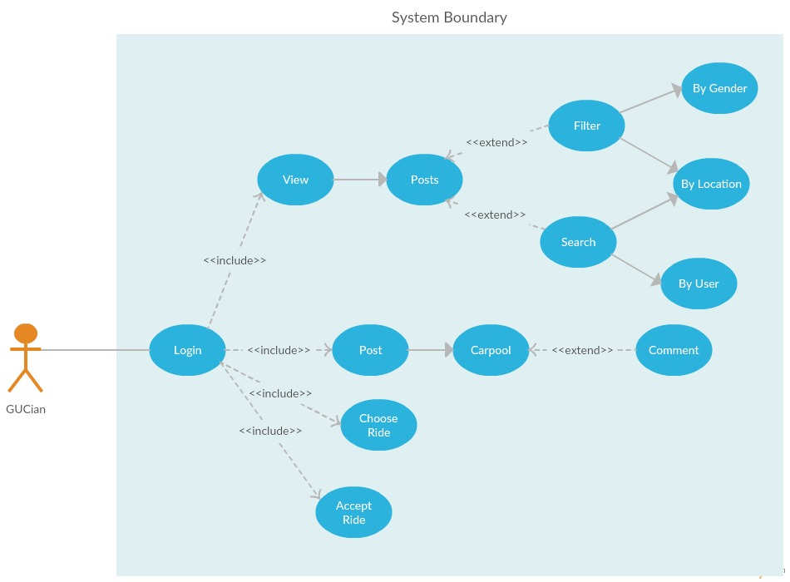
2. Scenarios

|  |  |
| --- | --- |
| 4.1. GUCian login. | |
| Actors: | GUCian |
| Pre-conditions: | none |
| Description: | As a GUCian I should be able to login providing my gu email and password |
| Guarantee: | Access al the features |
| Data: | Guc email, password |
| Trigger: | User click |
| Response: | Redirect to the main |
| Exceptions: |  |
| Comments: |  |

1. Sequence Diagrams
2. Class Diagram

Class: GUCian

Attributes: Name :String

ID :String

GUC Email :String

Gender :String

//Address (Can be changed to preferred meeting location.)

Methods: login(id, password)

logout()

createCarpool(description, location, date, time, availableSeats)

viewPost(postID)

comment(message, postID)

chooseCarpool(postID)

accept(postID, ID)

reject(postID, ID)

cancelRequest(postID)

cancelCarpool(postID)

searchPosts(searchKeys[]) (might return array of posts)

filterPosts(filterOptions[])

Class: CarpoolPost

Attributes: postID :String

GUCID :String

description :String

location :String

date :String

time :String

availableSeats :int

currentPassengers :String[]

possiblePassengers :String[]

cancelled :boolean

comments :ArrayList<String>

Methods: addComment(message, commenterID)

deleteCarpool()

removeCurrentPassenger(passengerID)

updateCarpool()

addCarpool() -- (Msh 3aref di eih)

acceptPossiblePassenger(passengerID)

rejectPossiblePassenger(passengerID)

addPossiblePasseger(passengerID)